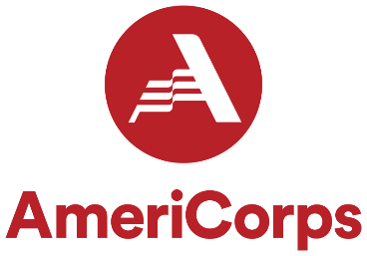

AMERICORPS/JUMP Program position 1 – Educational Data Specialist (300/100 hour position)
Responsibilities

- Work directly with and coordinate the JUMP program and Local School Personnel, specific to each case to record and track Mentee academic progress, attendance and general data in regards to grant requirements.
- Work directly with and attend meetings as scheduled with JUMP Program Coordinator, Court Liaison, AmeriCorps Program Personnel, and other Program Partners, as necessary
- Weekly supervision/reports with JUMP Program Coordinator and Court Liaison
- Assist with JUMP and AmeriCorps Program development
- Assist with completion of periodic JUMP Program progress reports
- Assist with development of program evaluation process
- Participate in monthly AmeriCorps Program Director calls, as needed
- Market and promote AmeriCorps and the JUMP Program
- Other duties as assigned
- All AmeriCorps/JUMP positions shall work in conjunction with one another. Assist one another as needed. Report to one another and JUMP/AmeriCorps staff as needed.

Requirements
- 18+ years of age
- Application
- Screening
- Provide 3 character references
- Thorough criminal background and child abuse records check
- Provide evidence of auto insurance
- Driver’s license
- Copy of Social Security card
- Enrollment as an AmeriCorps Member

Qualifications
- Ability to work independently as well as in a group setting
- Have basic computer and internet skills, including proficiency in Microsoft Word and Excel
- Strong communication skills, verbal and writing
- Demonstrate professionalism and courtesy
- Excellent time management skills
- Able to multi-task with solid planning, detail and organizational skills
- Effective problem solver
- Pass Federal and State background checks

AmeriCorps Member Requirements and Responsibilities
- Provide 3 character references
- Thorough criminal background and child abuse records check
- Provide evidence of auto insurance
- U.S. citizen or permanent resident: necessary documentation to demonstrate that by enrollment date
- Social security card by enrollment
- High school diploma or GED. If not, agree to get one before the end of service
- Attend required trainings and participate in AmeriCorps events
  - AmeriCorps Orientation Training
  - Complete required AmeriCorps eCourse trainings
  - 3 days of service (MLK Day, Veterans Day, AmeriCorps Week)
  - Regional Training Conference
  - National Service Opening Day in Springfield

AmeriCorps Member Benefits

- Stipend = (100 hours/300 hours of service)
  - Segal AmeriCorps Education Award – Minimum Time (100 hours/300 hours of service) AmeriCorps Members who are earning a Segal AmeriCorps Education Award are uniquely eligible for one type of postponement of the repayment of their qualified student loan called forbearance
  - If a member successfully completes their term of service and earns a Segal AmeriCorps Education Award, the National Service Trust will pay all or a portion of the interest that has accrued on the qualified student loans during this period
  - If a member is 55 or older at the time they earn the Segal AmeriCorps Education Award, the Award is transferrable to a child or grandchild
JUMP Benefits
- I Can Go to College Program – up to two years of fully funded post-secondary education through Kankakee Community College
- Continuing education and training
- Access to resources through Kankakee State’s Attorney’s Office partnerships
Revised 6/28//2022

