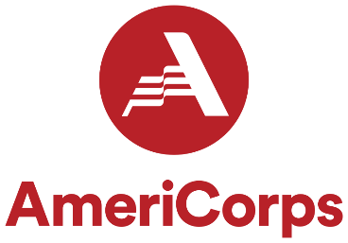

AmeriCorps JUMP Program Court Liaison (Full-Time 12-month commitment to perform 1700 hours)

Responsibilities

- Assist with AmeriCorps and Kankakee County State’s Attorney’s JUMP Juvenile Mentoring Program development; assist in developing program evaluation measures
- Work directly with AmeriCorps and JUMP Program Personnel and other Program Partners
- Weekly supervision with AmeriCorps or JUMP Program Coordinator
- Attend meetings as scheduled with AmeriCorps and JUMP Program Personnel and other Program Partners
- Attend fundraisers and events and meetings
- Attend court proceedings, teen court, and any necessary truancy meetings
- Report progress to presiding Judge of the Juvenile Division and keep juvenile probation officers, juvenile prosecutors and the mentee’s guardian ad-litem (if applicable) updated on the progress of the mentee
- Engage with school counselors and administration regarding attendance and academic progress of mentee
- Document the mentee’s progress in mentoring program, workplace and school setting
- Identifying other interventions or services to which the mentee may need a referral
- Input data on the impact of the JUMP Program and mentee’s overall progress in school, work, and court-imposed requirements
- Other duties as assigned

AmeriCorps Member Requirements

- Provide 3 character references
- Thorough criminal background and child abuse records check
- Provide evidence of auto insurance
- U.S. citizen or permanent resident: necessary documentation to demonstrate that by enrollment date
- Social security card by enrollment
- High school diploma or GED. If not, agree to get one before the end of service
Attend required trainings and Participate in AmeriCorps events

- AmeriCorps Orientation Training
- 3 days of service (MLK Day, Veterans Day, AmeriCorps Week)
- Regional Training Conference
- National Service Opening Day in Springfield

AmeriCorps Member Benefits

- Living Allowance- Full-time (1700 hours):
- Education Award- Full-time (1700 hours):
- Loan Forbearance o AmeriCorps Members who are earning a Segal AmeriCorps Education Award are uniquely eligible for one type of postponement of the repayment of their qualified student loan called forbearance
  - If a Member successfully completes their term of service and earns an Education Award, the National Service Trust will pay all or a portion of the interest that has accrued on the qualified student loans during this period
- Child Care Benefit Program available to active, full-time members if qualify
- o The AmeriCorps Child Care Benefit Program is available for qualified, active fulltime AmeriCorps Members who need the benefit to serve
  - Child care benefits are paid to qualified child care providers for all or a part of the Member’s child care costs during their active time of service with AmeriCorps
- Health Care Coverage available to active, full-time members if qualify o Healthcare insurance is available to those members serving a 1700-hour full-time term who are not otherwise covered by a healthcare policy at the time the member begins his/her term of service

Qualifications

- Ability to work independently as well as in a group setting
- Have basic computer and internet skills, including proficiency in Microsoft Word and Excel
- Strong communication skills, verbal and writing
- Demonstrate professionalism and courtesy
- Excellent time management skills
- Able to multi-task with solid planning, detail and organizational skills
- Effective problem solver
- Pass Federal and State background checks

